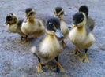
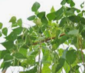
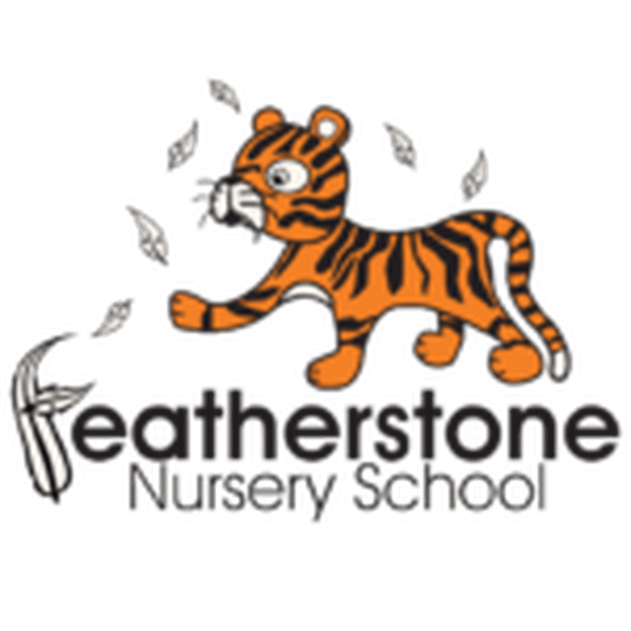
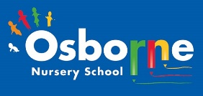
Summer 1 - Growth and Change
Federation of Osborne and Featherstone Nursery Schools Curriculum Guide for Parents and Carers
2 Year Olds | 3 Year Olds | 4 Year Olds
Key Activities:  The children will look for changes in their environment. They will talk about what they can see and what might be different. They will look at changes in themselves.  The children will be planting seeds and plants and observing their changes. They will explore different environments and taught new words. | Key Activities:  The children will learn about the lifecycle of a duckling—they will observe them hatching! They will be able to talk about what we need to stay alive and survive—water, warmth, food sleep, and care.  The children will explore similarities and differences around. Them. They will talk about what they can see and learn new language to help them explain. | Key Activities:  The children will look after the ducklings—feeding and cleaning. They will learn about their needs. They will compare needs of other animals,  They will care for the plants in the allotment and be able to describe changes. They will be able to name healthy foods and describe their taste. They will also talk about their likes and dislikes and explain why.
Core books to read:  The Very Hungry Caterpillar by Eric Carle. Oh Dear No Eggs Here! By Rod Campbell, Jaspers Beanstalk by Nick Butterworth and Mick Inkpen.  Non-fiction books about sunflowers and plants around us. | Core books to read:  Jack and the Beanstalk, Oliver’s Vegetables by Vivian French, Creepy, Crawly Calypso by Tony Langham. Where are my Chicks? By Sally Grindley and Jill Newton. Non-Fiction books about plants and animals. | Core books to read:  Egg to Chicken by Camilla de la Bedoyere and other non-fiction texts  Handa’ s Hen by Eileen Browne, Rosie’s Walk by Pat Hutchins, Titch by Pat Hutchins, The Hen That Wouldn’t Give Up by Jill Tomlinson.
Important words to learn:  Change, different, the same  Night, day, sunny, wet, cold, hot  Language to compare - big, small, hot, cold, Language linked to plants—colours, leaf seed, soil, water | Important words to learn:  Life cycle, lay, food, water, care warmth, shelter, growth and change. Language to compare size - large, small, tiny, huge, taller, shorter Language of number— more and less, counting objects | Important words to learn:  chick, egg, birds, hatch, develop, grow, shell, embryo, egg sack, egg tooth, membrane.  Words linked to survival—water, warmth, nutritious food, care, rest Times—morning, afternoon, evening, am. Pm, second, minute, hour, day, month, year, sun rise, sun set
How can you help at home? Talk about the weather when you get up. Look at different flowers in the supermarket or in gardens. What do plants need to grow? READ—lots of story times. | How can you help at home? Talk about animals you see out and about. What do they need? Talk about the care children need? Compare objects and talk about their size. Read lots of books and listen to story times | How can you help at home? Build and read words together—pit, cat, mat. Listen to the stories in Tapestry. Talk about how we care for animals and how we care for each other. Discuss times of the day—what to do we do when?

